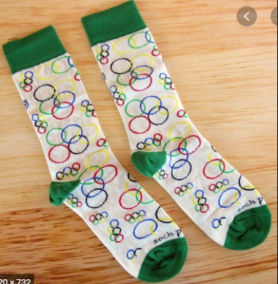
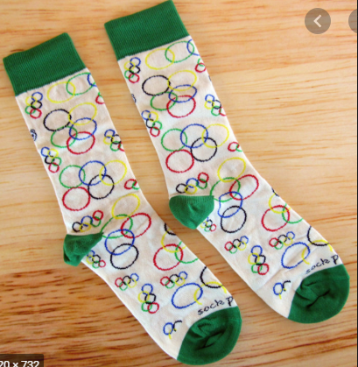
Welcome to the
Barham School
Sock Olympics!

This year, Sports Day is looking a little different! To fill the void left by the postponement of the traditional Barham School Sports Day and the Tokyo 2020 Olympics, we have planned The Barham School Sock Olympics just for you!
You will need:
A ball of socks!
Your trainers
Stopwatch/timer
Laundry basket, bucket or hoop
6 skittles (toilet rolls or empty plastic bottles)

When you have completed the activities, send a photo of your scorecard to your class teacher. We will then count the points to find the winning Olympic house!
Have a go at the different activities and record your scores on the scorecard!
You can see Year 6 demonstrate each activity on the Year 6 Class page.
We would love to see any photos of you completing the events!

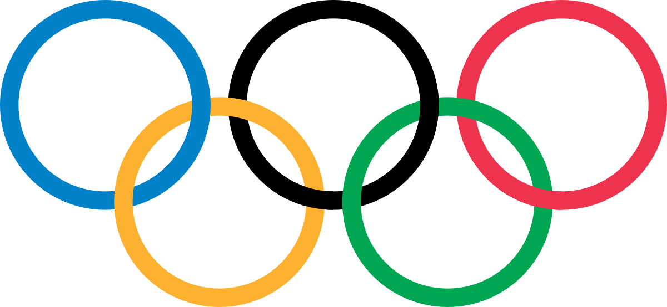
‘
Chaucer
Marlowe
Roper
Becket
Barham School
Sock Olympics
Results Table!

Sock Throw
Choose a starting position then see how far you can throw your ball of socks. Use an overarm throw.
Measure your throw using your own feet! How many of your feet (heel to toe) did you throw it?

Sock Keepy-Uppies
Can you keep your ball of socks up in the air using just your feet?
How many keepy-uppies can you do in 1 minute?

Sock Basketball
Put a bucket, laundry basket or hoop 4m away. How many times can you throw your ball of socks into the bucket, collect, return and throw again in 1 minute?

Sock Catch
Drop your ball of socks behind your head then quickly try to catch it between your legs! Have a practice first! How many can you catch in 1 minute?

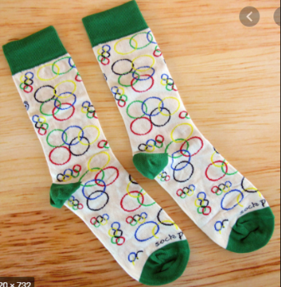

Rainbow Sock Throw
Put your socks into one hand and throw to your other, like a rainbow arch! How many rainbows can you throw in 1 minute?

Jump In Your Socks
Put your socks and trainers on for this one. Stand still and jump as far as you can! Measure your jump using your own feet! How many of your feet did you jump?

Sock Jump
Place your ball of socks on the floor and see how many times you can jump over them and back in 1 minute!

Sock Bowling
Set up six skittles (toilet roll tubes or empty plastic bottles). Stand 3m away and use your ball of socks to knock them down! How many can you knock down in three separate throws?

Barham School
Sock Olympics Activity Card!
Sock Throw

How many of your own feet (heel to toe) did you throw it?
Sock Basketball

How many can you score in 1 minute?
Sock Catch

How many can you do in 1 minute?
Sock Keepy-Uppies

How many can you do in 1 minute?
Jump In Your Socks

How many of your own feet (heel to toe) did you jump?

Sock Jump

How many can you do in 1 minute?

Barham School
Sock Olympics Scorecard!
Name______________ House_____________ Class ___________

Total score

Rainbow Sock Throw

How many can you do in 1 minute?

Sock Bowling

Have three goes!
Your score will be out of 18!
Class Scorecard
Becket |  | Chaucer |  | Marlowe |  | Roper
Name | Total | Name | Total | Name | Total | Name | Total
Total |  | Total |  | Total |  | Total

