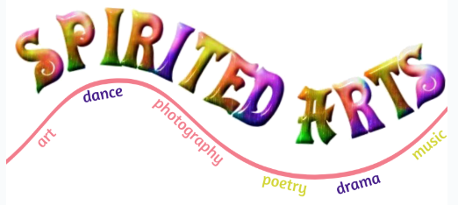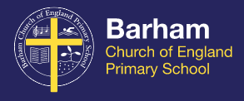
Hello lovely Barham pupils!

This week’s RE challenge returns to the national Spirited Arts competition.
This is the second of 5 themes suggested for the challenge. Do feel free to take a look at the website and check out the other themes if this one doesn’t capture your imagination! All of the information can be found at https://www.natre.org.uk/about-natre/projects/spirited-arts/spirited-arts-2020/ Please send your entries along with your written explanation, to your class teacher or directly to Mrs Sharpe at Jodie.sharpe@barham.kent.sch.uk

This Week’s Theme: Where is God?

Atheists, agnostics and believers in God might all respond to this by expressing their sense of the search for God or finding God. Where’s God? In your heart, in prayer, in the temple or the universe? Or is she hiding? Is he not there at all? Looking for God, searching for him or her, matters: but how are we doing in finding God? Would you search with google or a ‘God detector’? Is God on Instagram or WhatsApp? Can God be found by prayer or by looking among the world’s suffering people?

Entries are welcome in (almost!) any art form you can think of, including:
* Art (painting, drawing, sketching etc.)
* Poetry
* Photography
* Dance
* Music
* Drama
* Sculpture

Winning entries will provide a good response to one of the 5 themes, and judges will be asking is it original? Is it well-crafted? And (most importantly!) is it excellent RE? Entries should consist of a piece of art and a corresponding write up of no more than 400 words. The write up should support the main piece in responding to the theme and showcase the brilliant RE your pupils are doing. The commentary is a large element of judging, and authentic commentaries demonstrating pupil knowledge and interpretation always rank highly.

